Renju lesson on December 7, 2000

Hello all! Welcome to Online Renju Class.
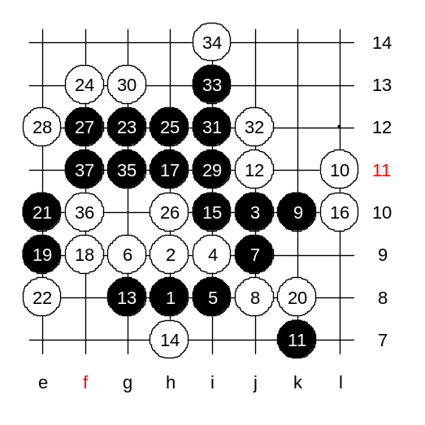
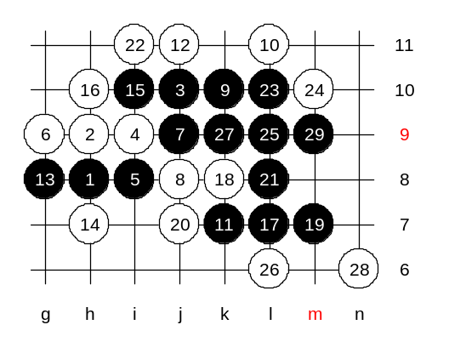
We will begin today's lesson. Last week we studied about 5-i8. We will continue with it today. Today's topic is 8-j8. Nakamura used that 8th move when he beat me in the first game of the match. There are three possible continuations for black. Do you know which moves? Concord is right - black's choices are h10, f9, k10. Any other move practically gives white win. Moves h10 and f9 give the same position in most cases. Move k10 has different style. Black is active here. But if white defends correctly, then the outcome is good for white. However, it is not easy to make correct moves without having good knowledge about it. Even in the WC finals, players make mistakes. After 11-k7 blacks looks very strong. There is only one move after which black does not win. Do you know where is it? Where should white play now? The correct move is 12-j11. It is such a wonderful move - black does not have VCF attack, and black cannot continua with soft development either because white has already some material in the upper side. Move 13-g8 is perhaps the best answer. If defends something, and also keeps black structures alive. Should white continue actively or passively? Lets find out. We play passive move first. Actually, some years ago, in the World Championship finals, Nara (9dan) used that move as white. Sinyov was black in that game, and he proved fast that black has sure win here. Lets see how the game was played. Nara played L10. After 17-h11 black has VCF threat on the left side, do you all see it? So, white must play a four first. Black win is still quite easy, as you see.

Lets see what happens if 16th move is played to other side.
How does black win? Everybody says that L7 is the first move. Lets play it then.

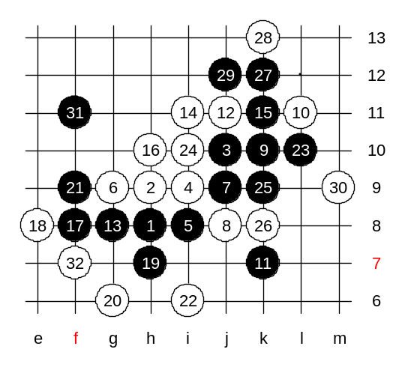
Lets learn about the correct white 14th move. We saw that passive style was not good for white. Therefore we play active 14th move now - i11. As you see, white gets the advantage here. Black is forced to block 33-h5 and then white gets the initiative.

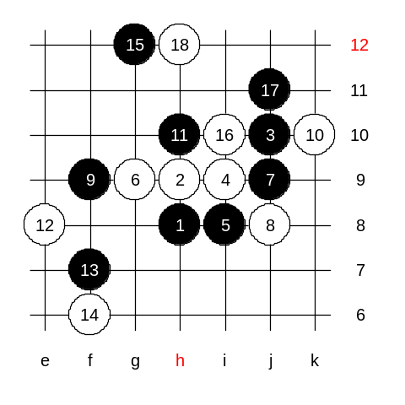

Another 9th move. White plays k10 here and then 11-h10, which leads to the same position with 9-h10. Move 12-e8 is the passive style. By the 18th move the position is equal. Move f7 is a good move in positional style. It takes important point from whites.

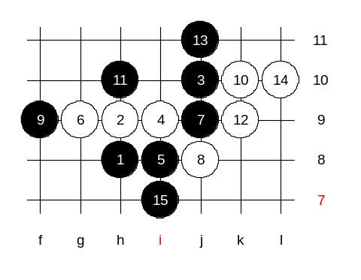
Another 12th move. Active style. Nakamura used this move against me.
The correct move would be 15-m11. Lets suppose black plays wrong move - i7. This is the medium level homework. Please find white win.

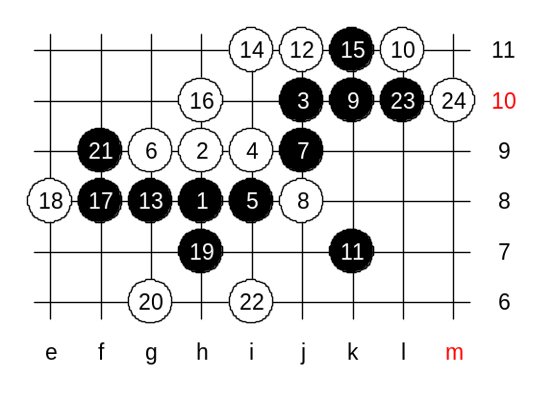
This is the advanced level homework.
Please find black win.
The homework is easier than last week homework, I believe.

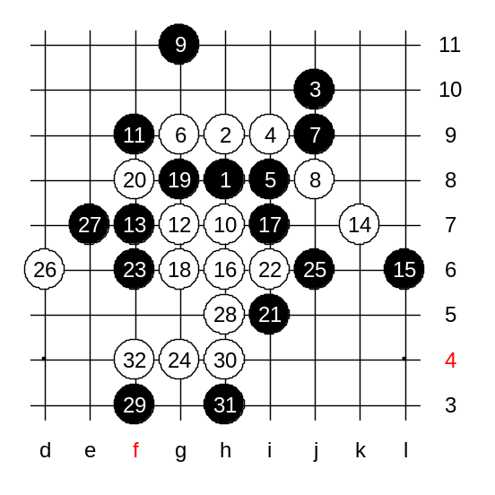

I announce the official part of the lesson to be finished. Those who want to stay here, may join the game teacher vs students. As usually, I choose some gambling move at some point. And you will have a chance to win. but the win will not be easy and requires good teamwork. We use the opening according to today's topic. Move 9-g11 enough crazy move. Good luck to all of you now.
Good game! You won again! Congratulations! Next week, I will play some stronger position. And so on, every week harder.

